Assignment 06 – Transfer function

# Paraview

I explored 3 datasets in paraview, namely, tooth, engine and hydrogen.

In general,

1. I first loaded the dataset into paraview. After choosing volume rendering, I enabled the histogram view to understand the scalar data distribution in the dataset.
2. If its difficult to visualize because the distribution is extremely skewed, then I used log of distribution to dampen the effect of skew.
3. Then, I would change color & opacity transfer functions by adding new points & moving them around until I find an interesting visualization.

Here are some screen shots of the exploration.

**Engine**

Step1:

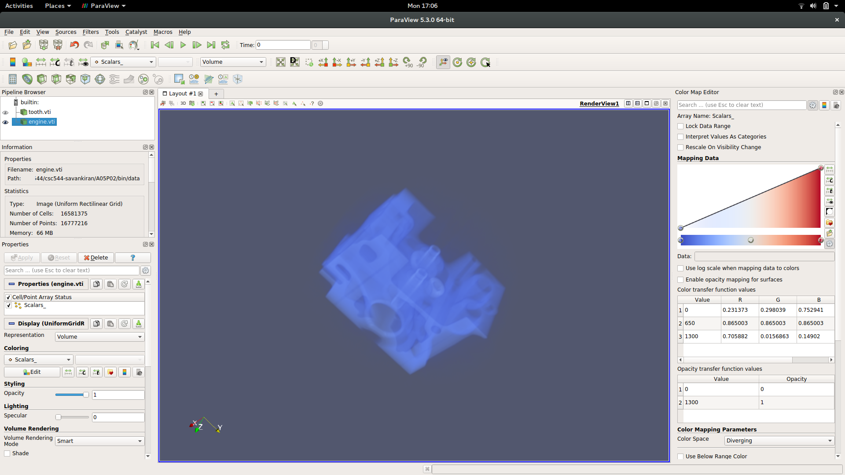

Step2:

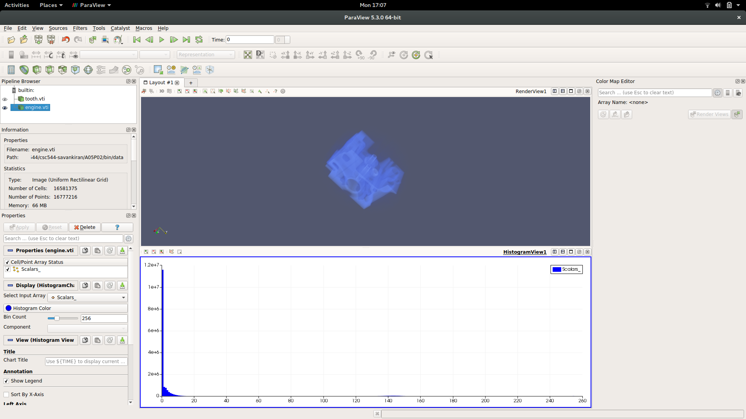

Step 3:

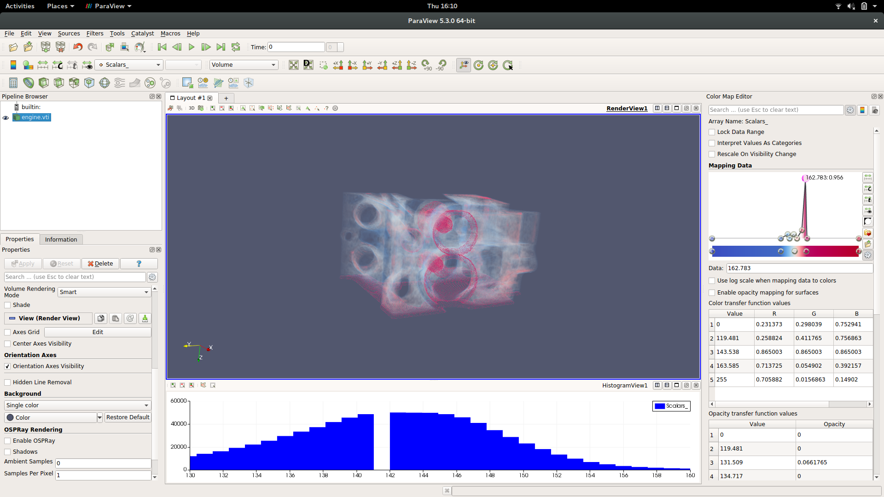

Other adjustments of color & opacity Tfs.

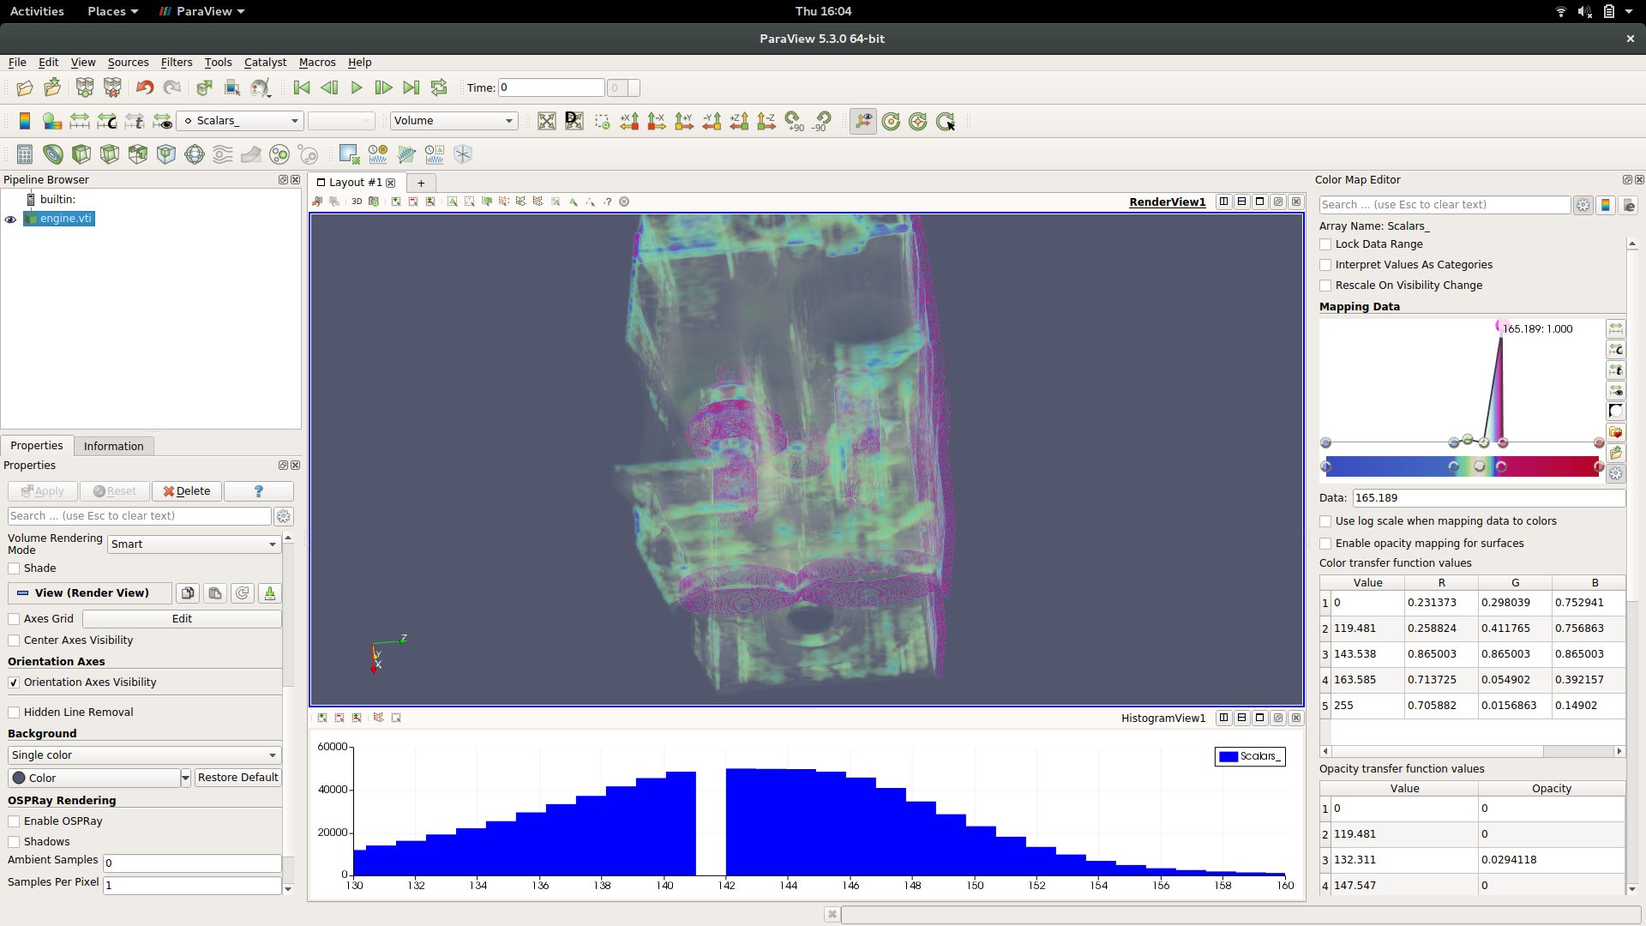

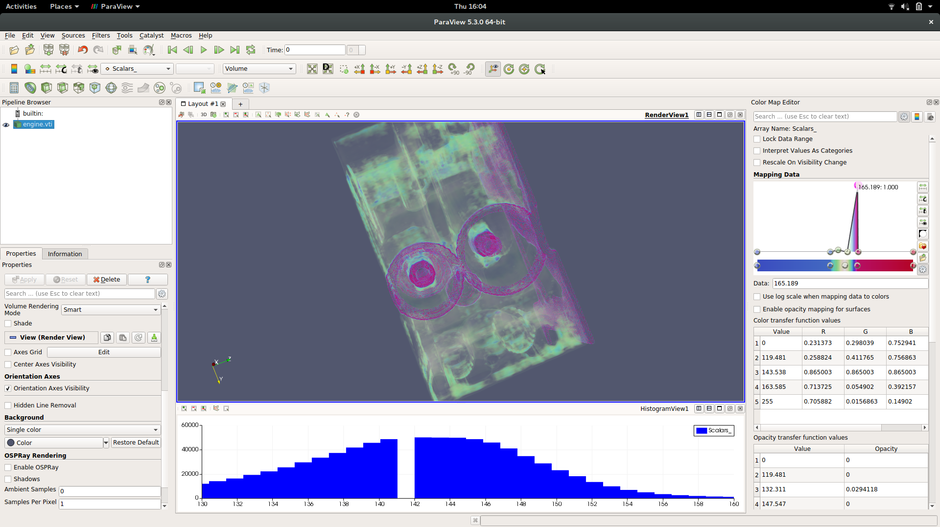

**Tooth**

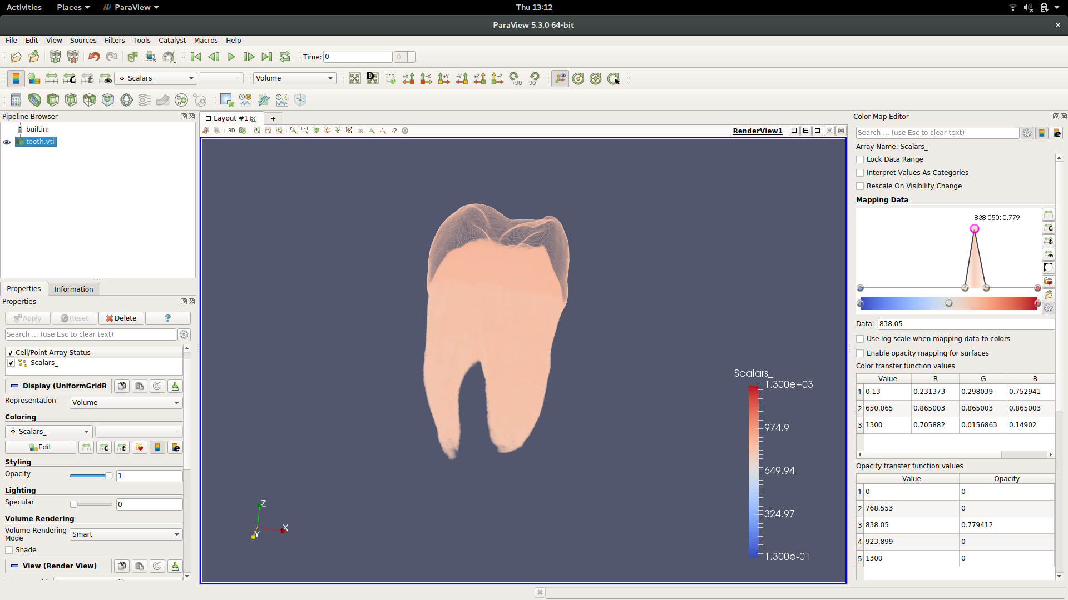

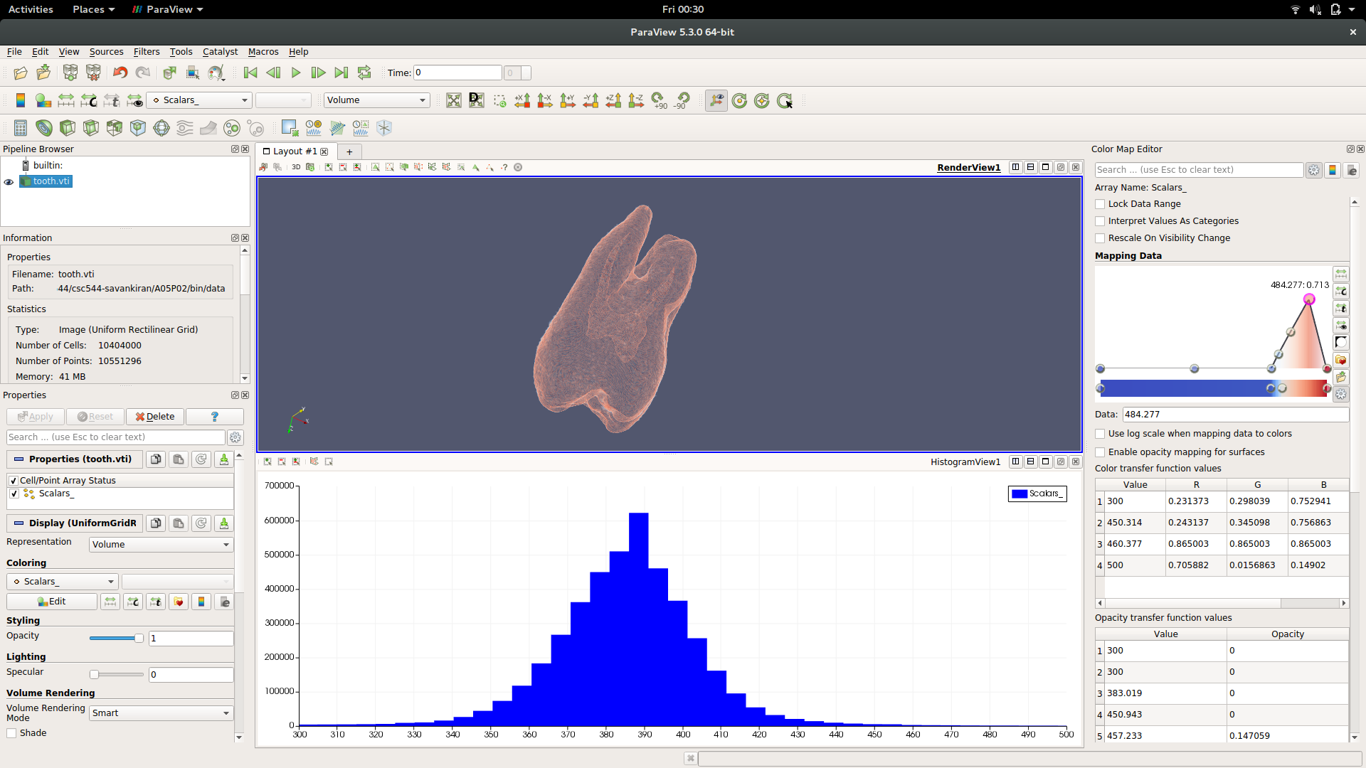

**Hydrogen**

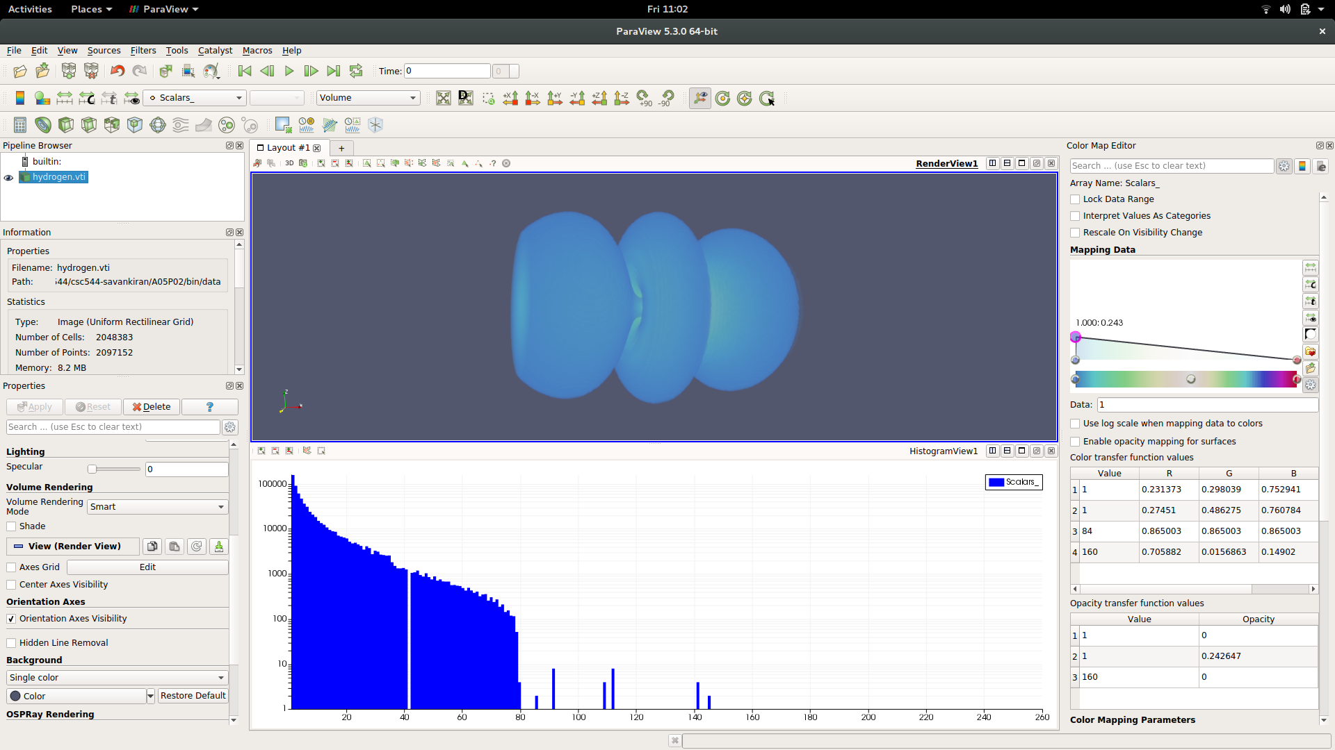

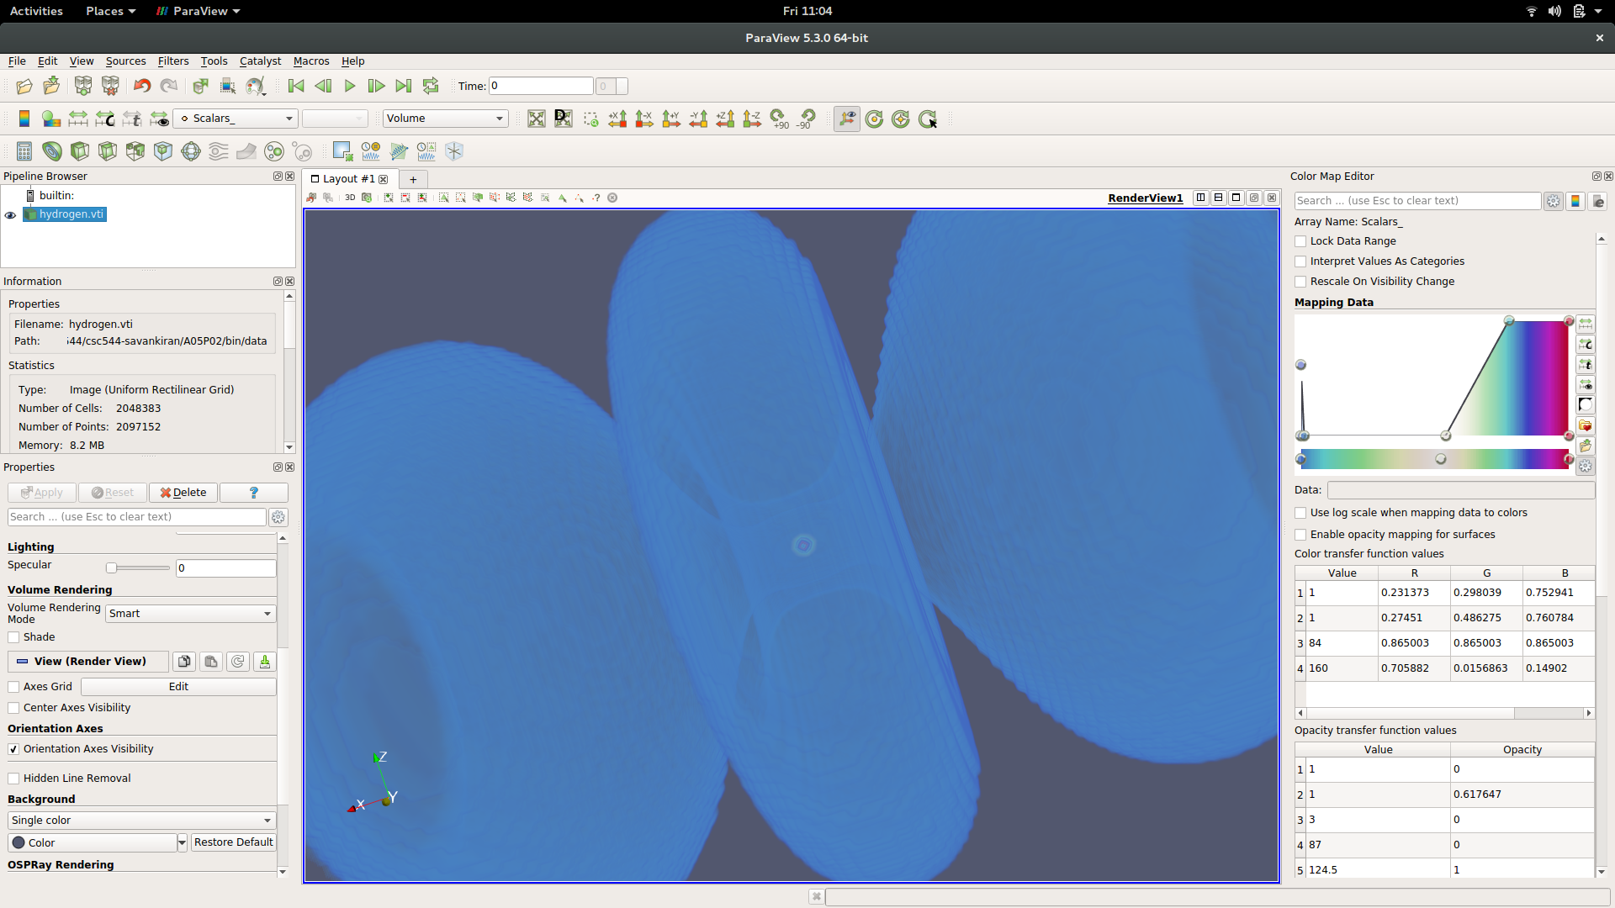

Inside of hydrogen molecule which binds the 2 atoms.

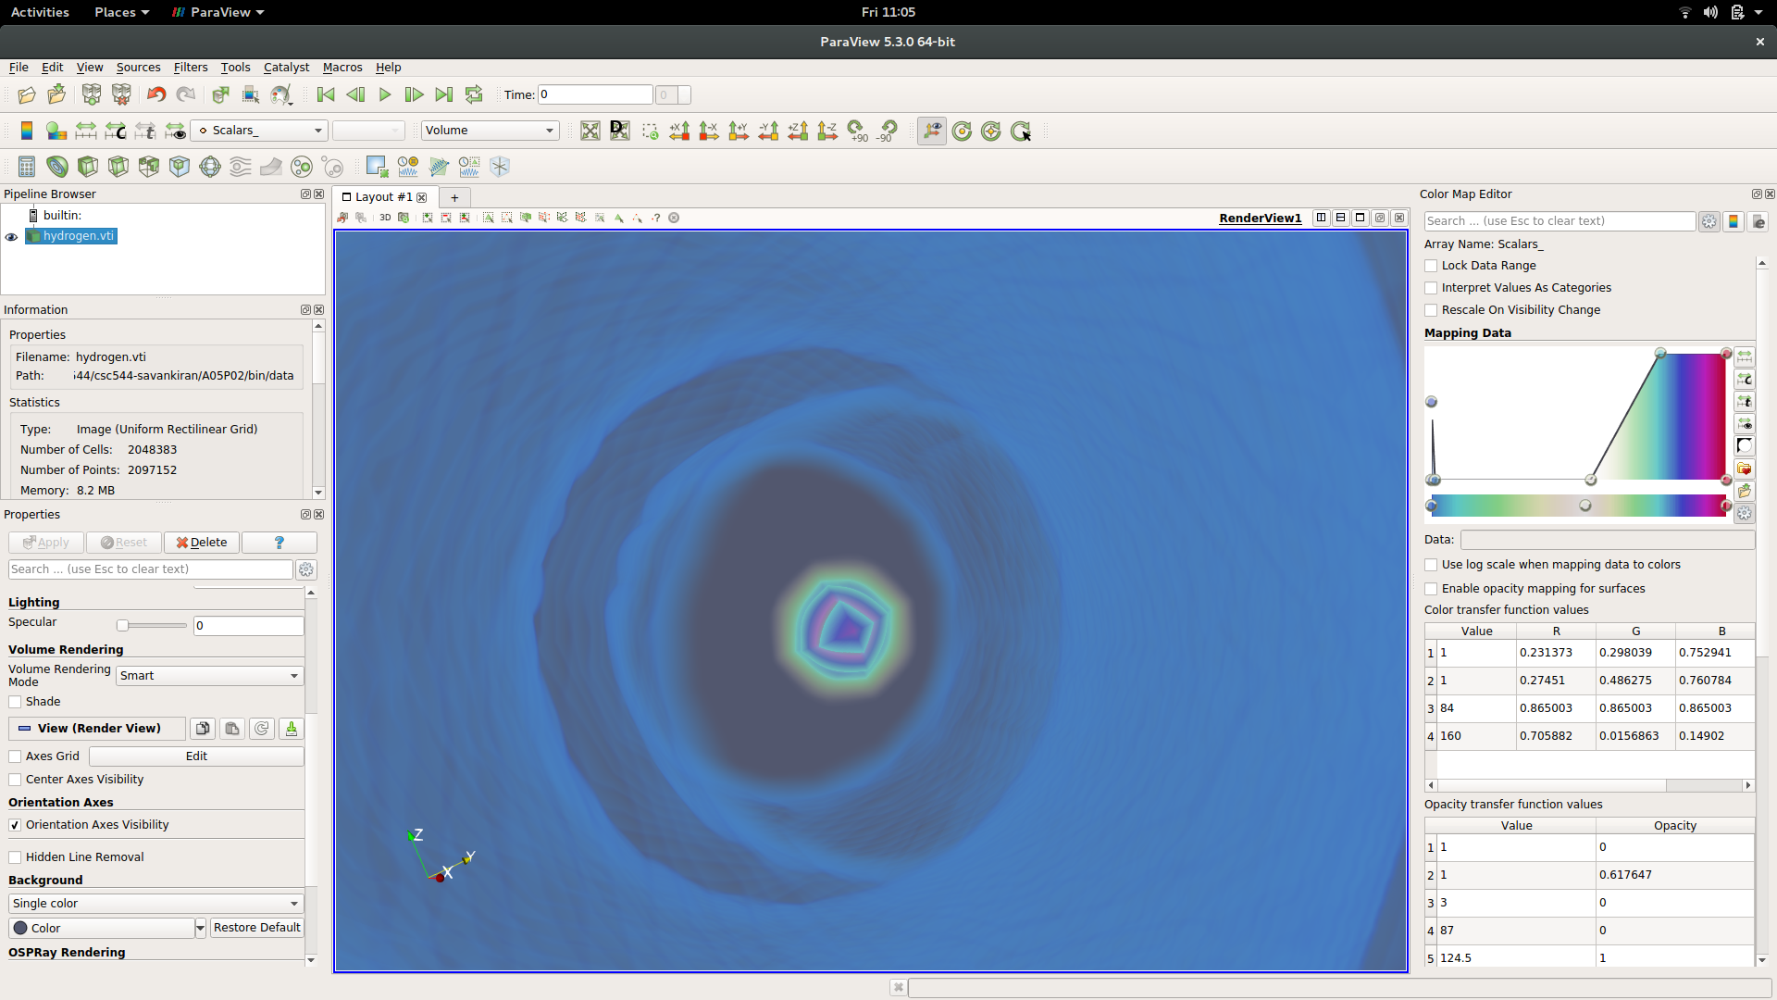

I really liked the paraview’s transfer function. It was intuitive and very easy to use. I could do fine adjustments to color & opacity points. With this, I was able to create many interesting visualizations. All I needed was the graphical color & opacity widgets. It was good that I saw the precise values in table below but there was no way to hide them as I didn’t need them all the time. Also I really liked the different color space that I could use. Just wish it was above all those big tables as I took a long time to figure it out. It also took a long to time to know how to filter the data range. I would like to improve on these points in my transfer function widget implementation. Also taking the best parts like color & opacity TF graphical interface using color bands.

# Sample App

The sample app while being limited in functionality as compared to Paraview was still useful in finding the many relevant visualizations. The sample app didn’t provide any freedom to choose different colors & opacity for different data points like paraview. But it only represented one iso value and a small range around that iso value. There was also small fixed opacity range around iso value. With this limited feature set, one can still explore a lot of tooth dataset. However, one can’t explore other viz that shows many colors & opacity values. I was able to find the internal structure that looks like a tooth root that is embedded in the enamel & inside the gums.

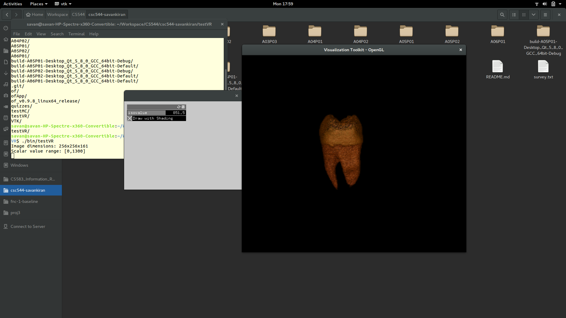

# New transfer function widget

For a useful 1D transfer function, all of the below are necessary -

* Mechanism to filter data range
* Add and modify color TF values intuitively
* Add and modify opacity TF values intuitively
* Change colorspace (between diverging/HSV/ etc)
* Mechanism to understand data distribution (something like a histogram)

There could be additional features as well.

I designed 2 alternative approaches.

1. Alternative 1: Design is inspired by Paraview for most part. The color & opacity TF pickers are very similar to Paraview & follow the same interactions. The dataset filtering in paraview is obscure and I wanted to fix this as I felt that it is a prerequisite for a good viz. So I added a slider to intuitively move the left & right bounds of the range and adjust what is drawn on screen. This helps in easily eliminating background noise in the dataset. To identify the background noise in the distribution, I have added a histogram at the start. This is where a user would be begin. He would try to understand the distribution first. If its hard to distinguish in regular, one can use log scale as it dampens the effect of large concentrated scalar values. With this information at hand, one filters actual dataset and starts adding color & opacity transfer functions. I kept it rather similar to paraview because I found it extremely effective & yet simple. It also contains a few more check boxes at the bottom to change color space, use above(below) range colors, etc.
2. Alternative 2: In this approach, I tried to unify the different parts of the widget into a widget that can viewed as a whole. I drew the opacity TF, color TF & data distribution (histogram) as concentric circles like a sun dial. The outer circle has radial histogram for data distribution. The intermediate circle has color TF which would behave very similar to Paraview’s color TF except that it is radial. And inner most circle is opacity TF which has 2D data <dataPoint, opacity>.

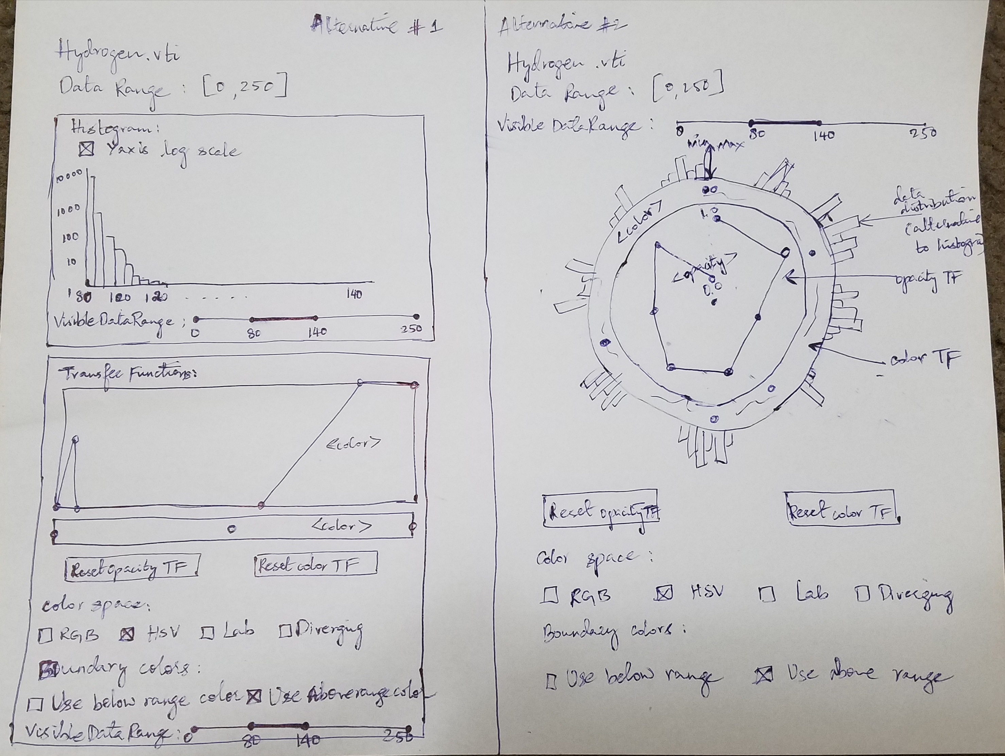

Although the 2nd alternative looks visually appealing, I felt that it made the UI clumsy. We also know that human perception of circles and areas are not that effective. As compared, alternative 1 seemed more clean and intuitive approach. That’s why I chose alternative 1.

# Exploring new widget

To load new dataset, please edit the first line of setup() function in ofApp.cpp.

**Tooth**

Soon after dataset is loaded.

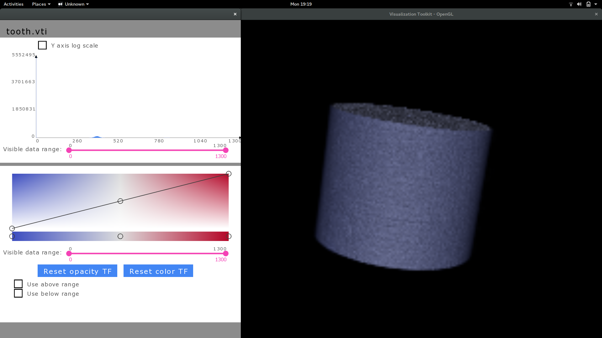

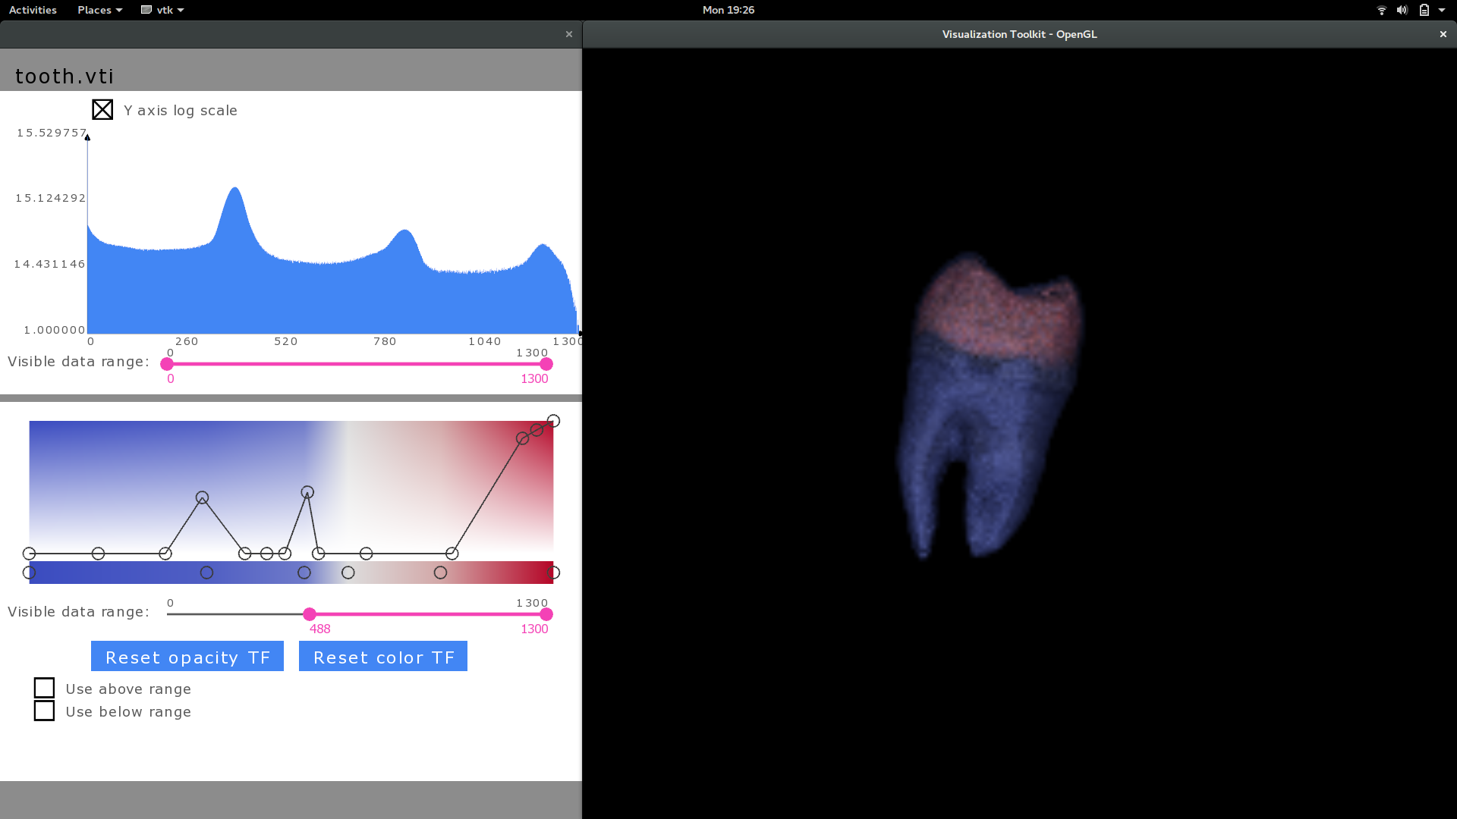

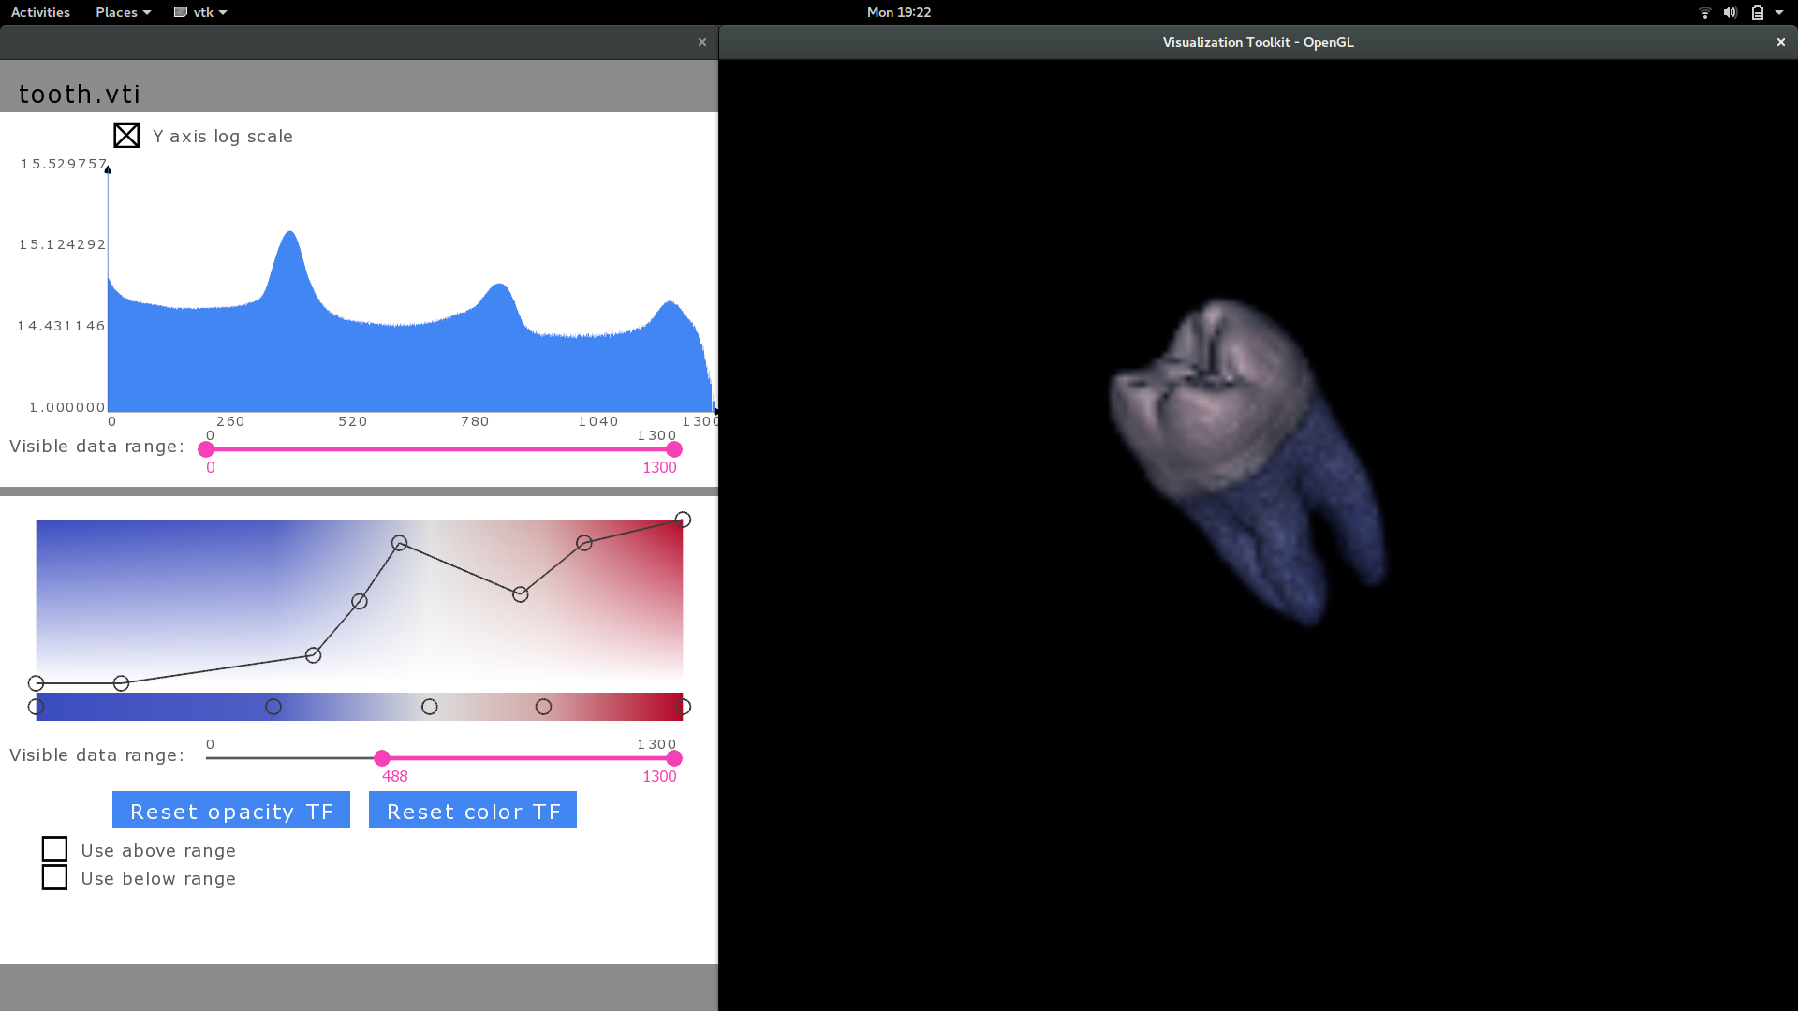

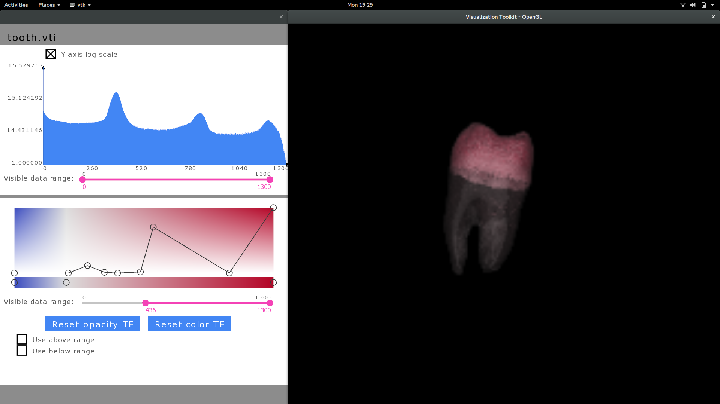

By changing color & opacity TF I was able to find different internal layers within the tooth that isn’t easily visible with simple volume rendering. I could find the root kind of structure that I earlier found in paraview. Also was easily able to distinguish between gum & enamel.

**Hydrogen**

I was able to find the same bond between the two atoms I found in paraview. I made the big bulbs trasnslucent & was able to find two regions within two bulbs(atoms) that have similar values like the force between the atoms.

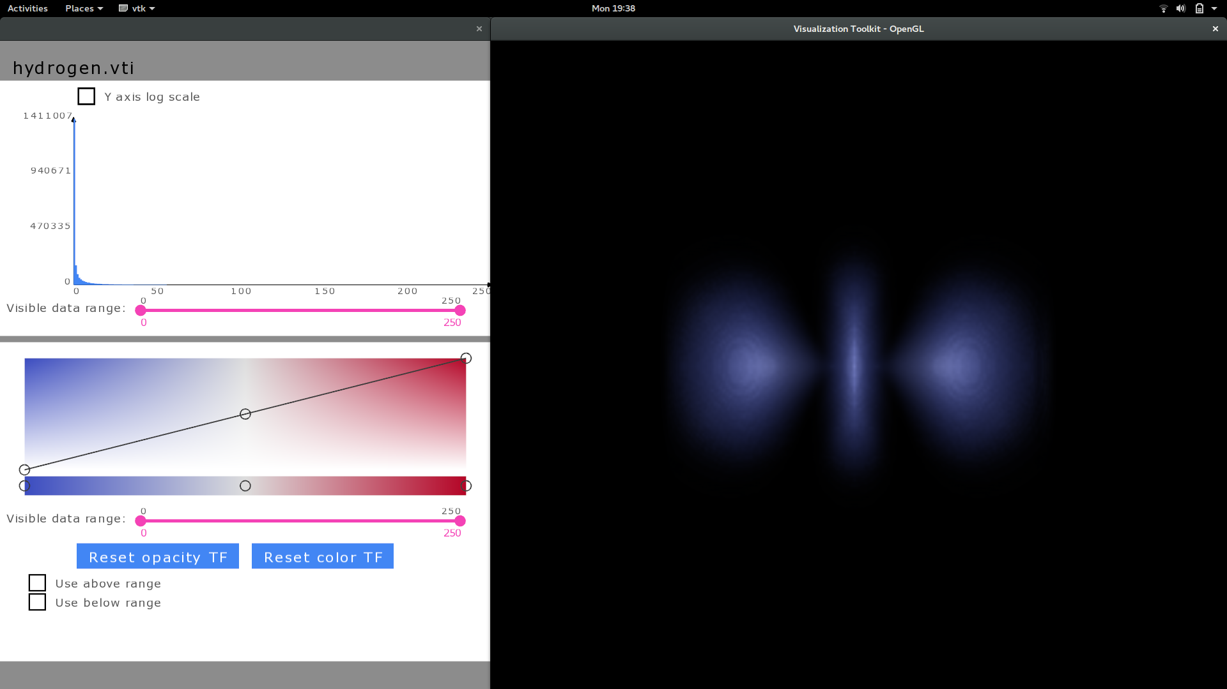

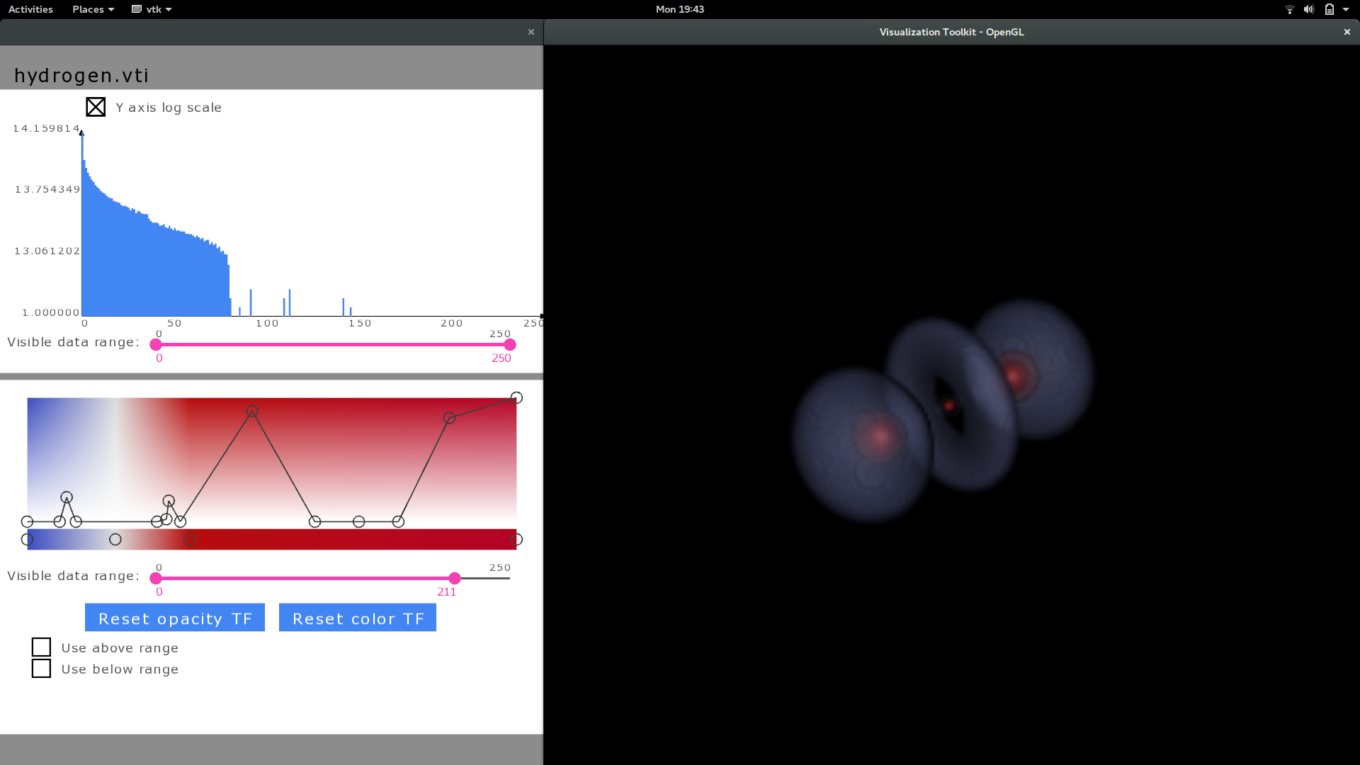

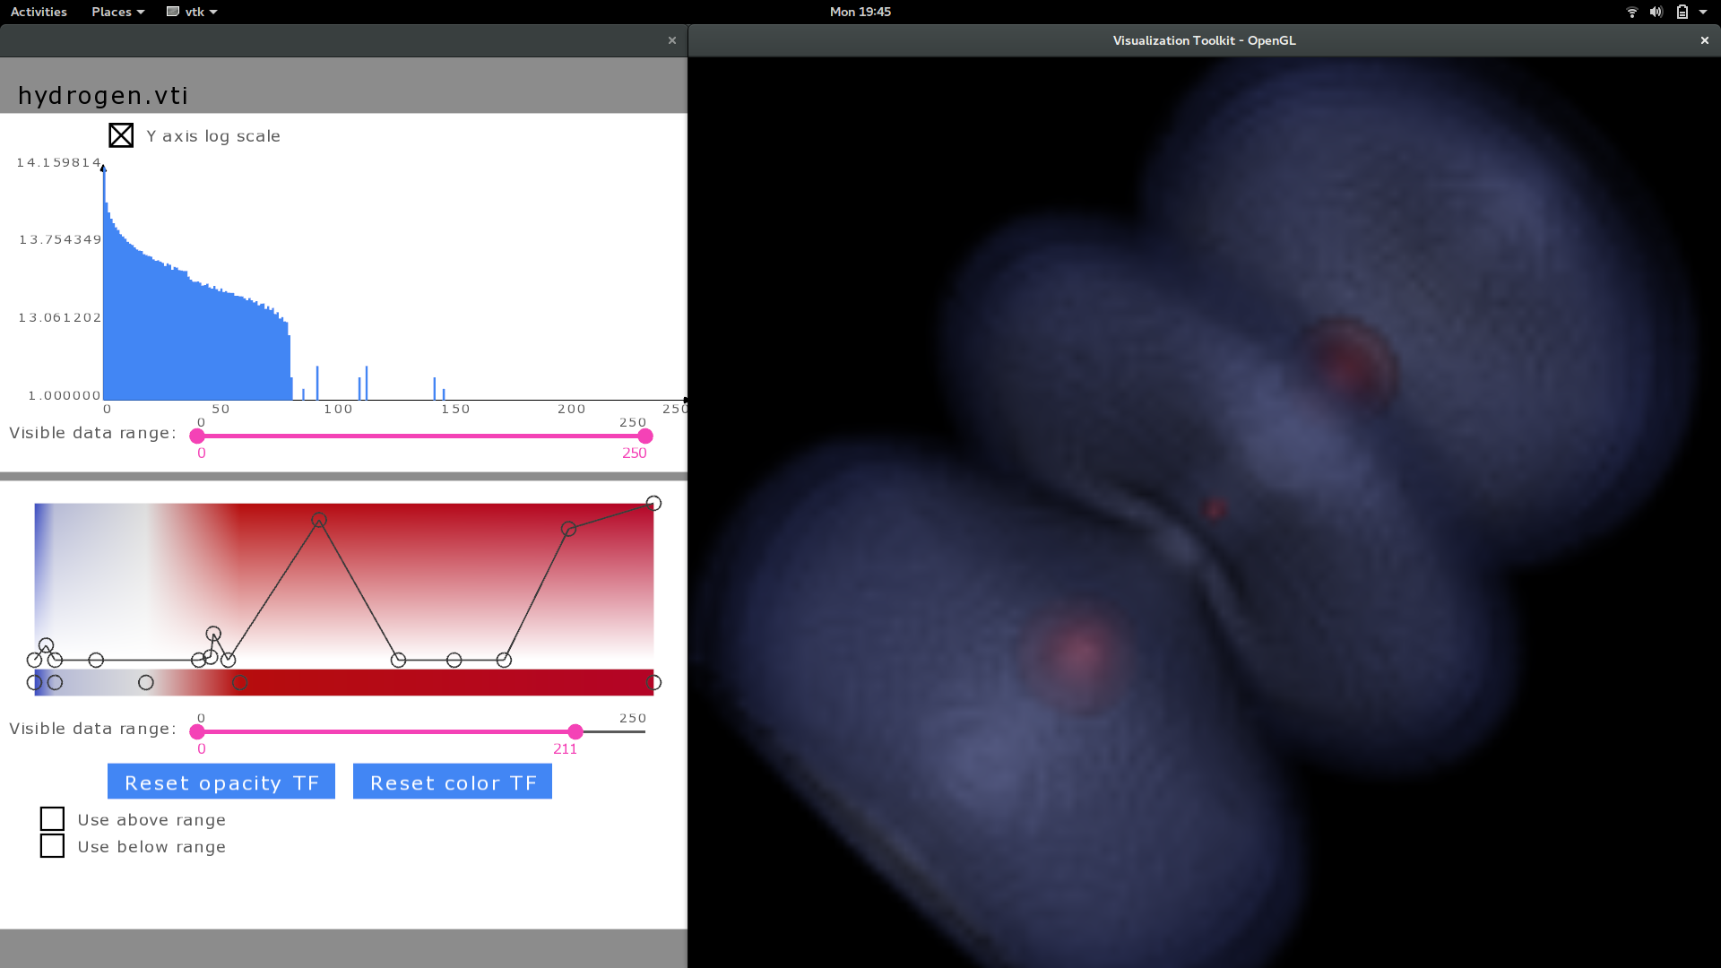

**Engine**

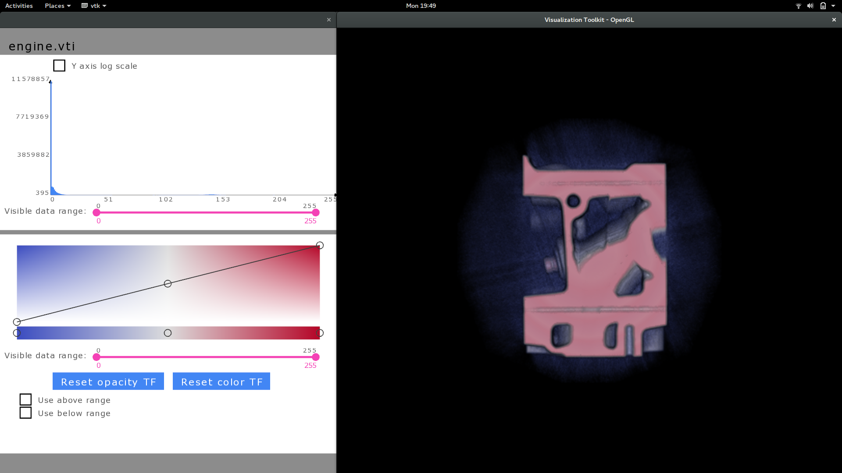

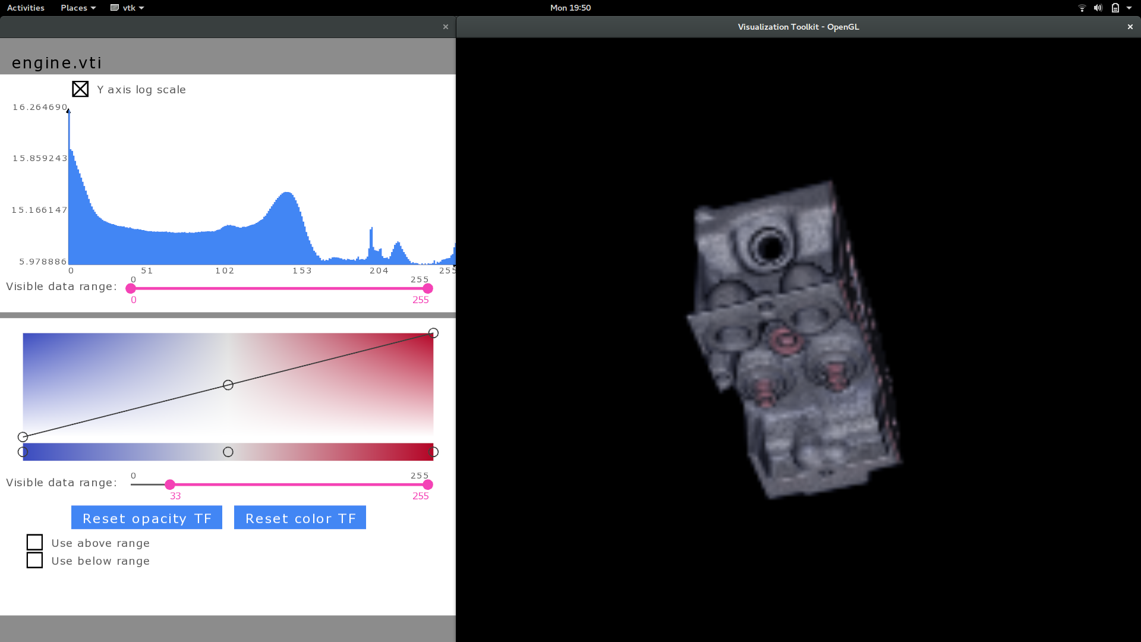

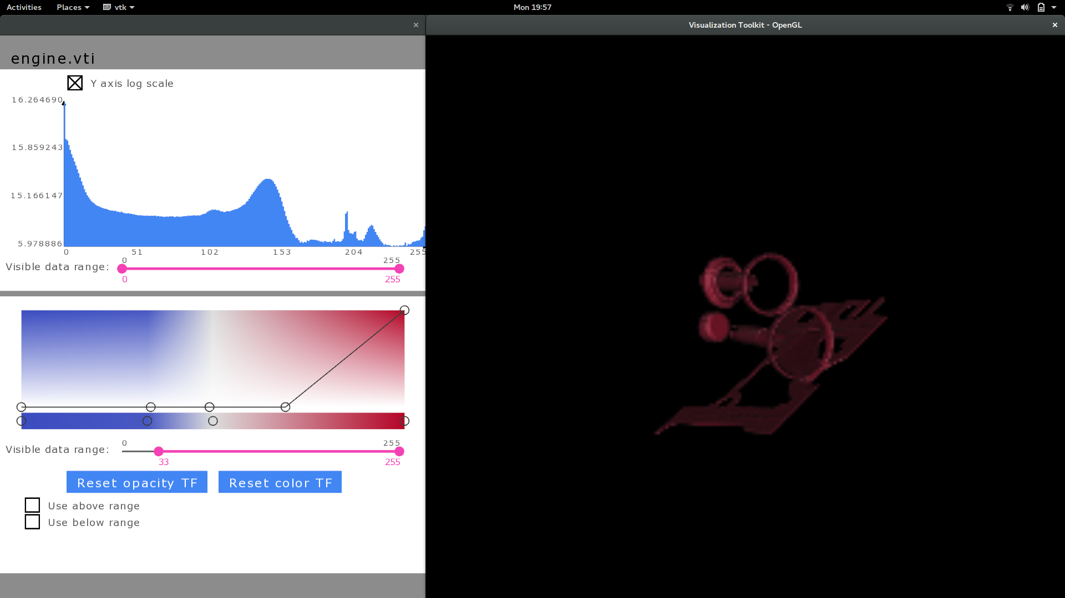

I was able to see the spindle & rotor kind of elements within the engine body.

**Stag**

I was able to explore the internal structure of the stag without the wings and external skin.

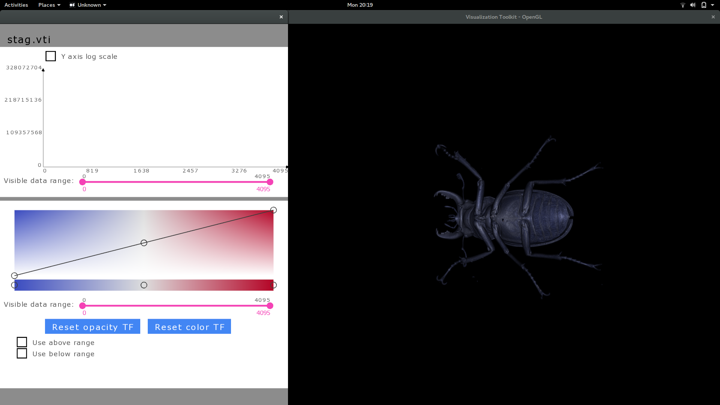

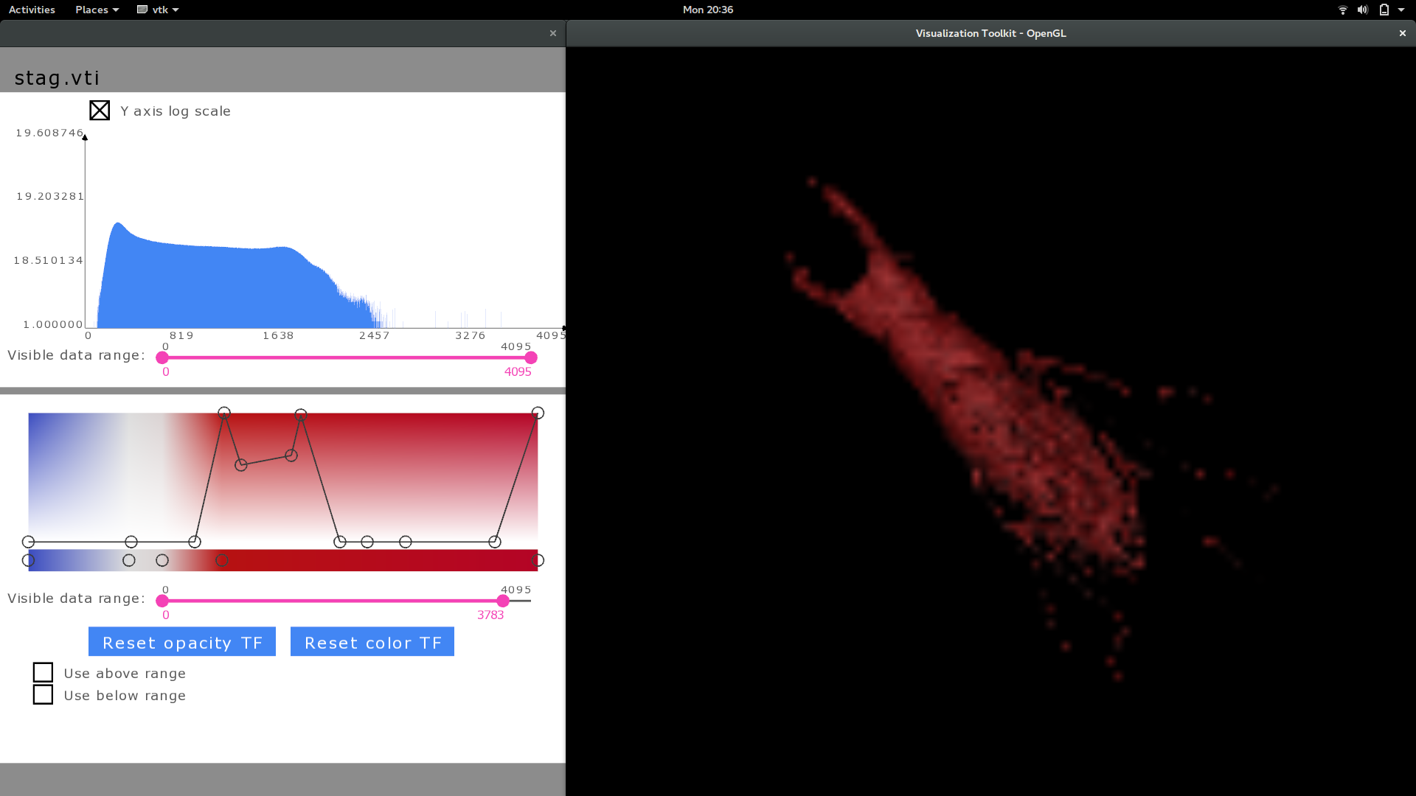

Strength of my widget is that it can pretty much do what paraview does and a few things like data range filtering better. I wanted to implement the various color space which I couldn’t do because of time. I would like to do that. I would also like to have a unified widget like the alternative 2 but a more intuitive & user friendly version of it.

Volume rendering as a technique is extremely effective in visualizing internal structures of a 3D model. However, it is very difficult to view various internal layers of the 3D model either individually or together. Hence the use of transfer functions widgets to simplify the task. Volume rendering is very important as it can depict information that can’t be perceived through either slice or iso value representation.